Project Design Phase
Solution Architecture — ACL Access Control

Date | 2 October 2026
Team ID
Project Name | Script-Controlled ACL — Branch-Based Record Access
Maximum Marks | 4 Marks

Solution Architecture: Script-Controlled Record ACLs
The architecture places ServiceNow record ACL evaluation between user-facing interfaces and the Institution Details table. Each table operation is checked against its configured role; READ also uses the Branch = EEE data condition and the administrator exception described in the lab.
- Enforce access at the record-ACL layer for each requested table operation.
- Separate the branch-scoped READ condition from the CREATE, WRITE, and DELETE role gates.
- Represent the user roles and branch values explicitly so allowed and denied outcomes can be tested.
- Validate requests through ServiceNow lists/forms and, where enabled, Service Portal; the source does not document a production deployment.

ACL architecture and access flow:

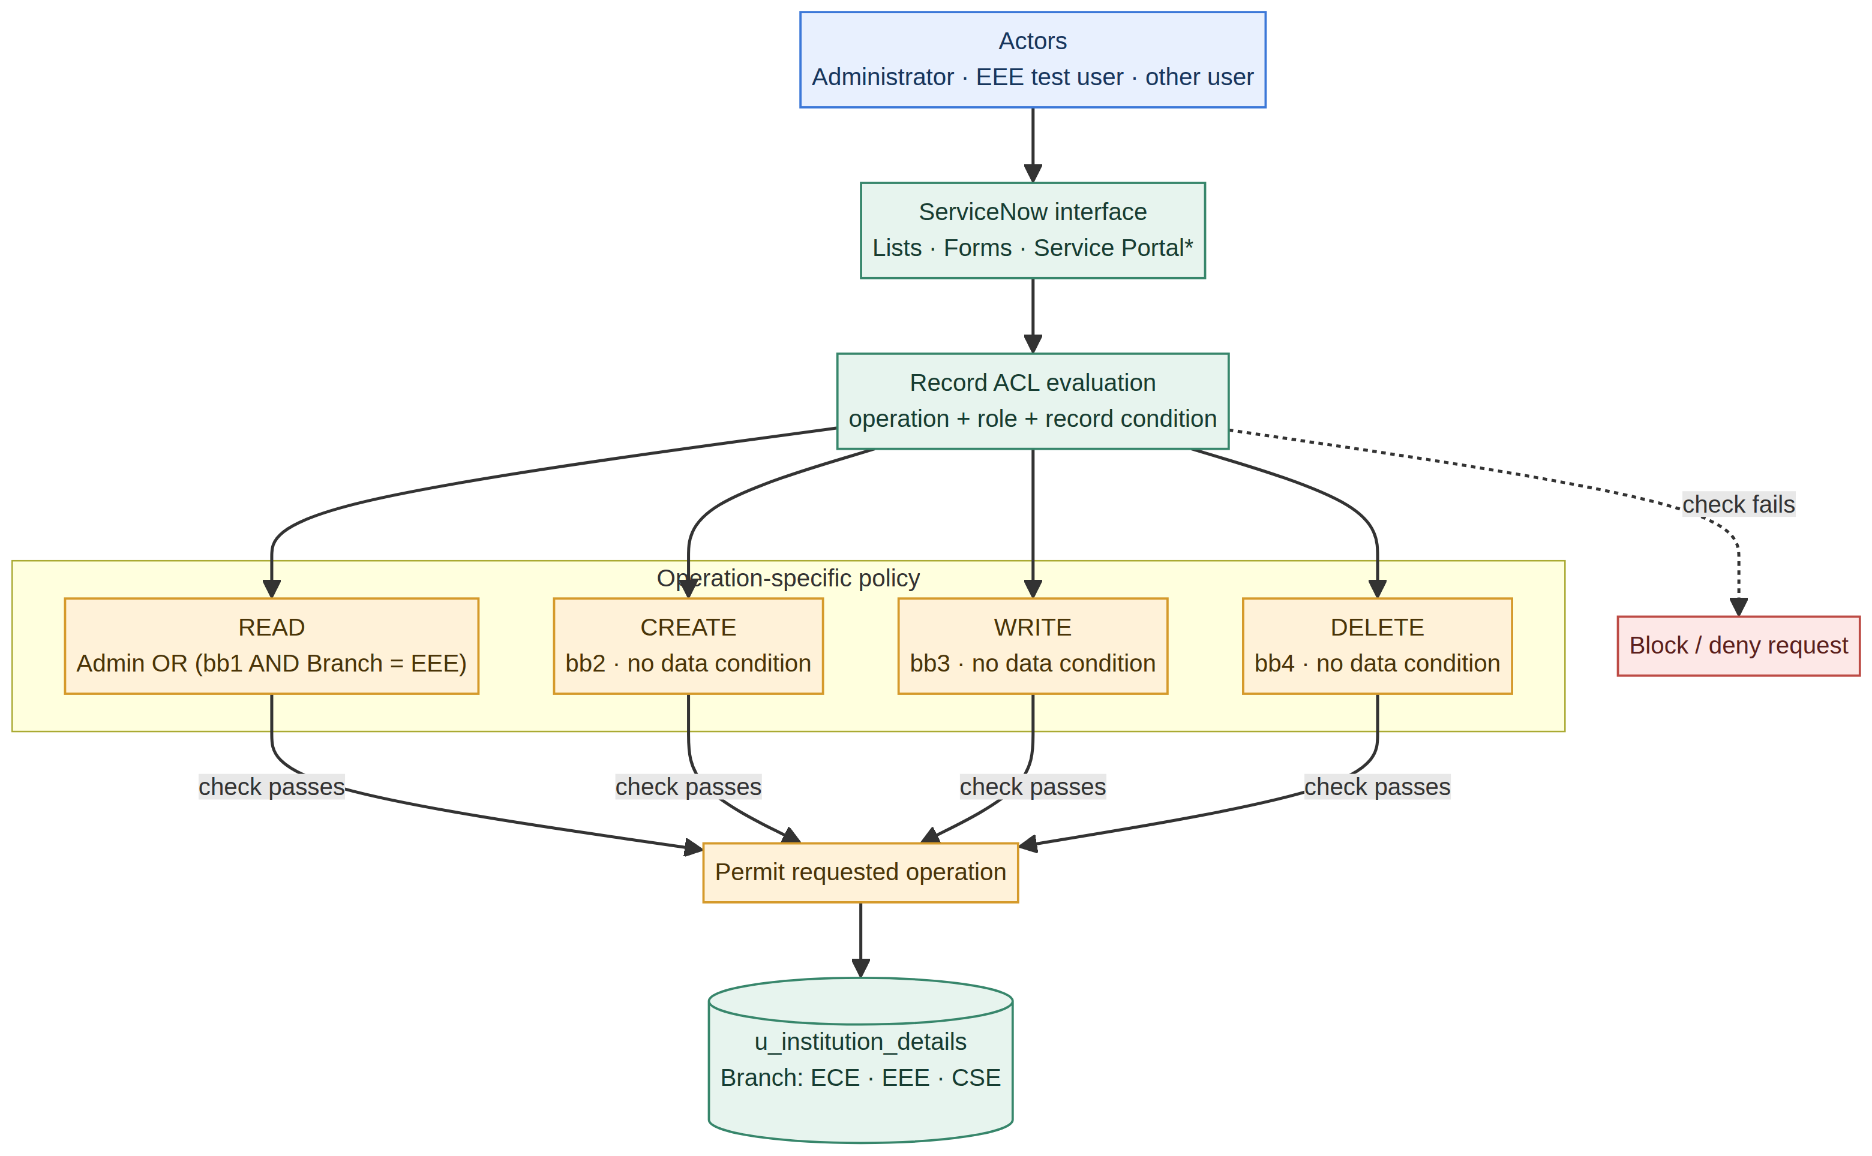
Figure 1. ServiceNow ACL flow and operation-specific role gates (based on the supplied lab).

Component | Responsibility / configuration
Actors and roles | Administrator and EEE test user; custom roles bb1 (READ), bb2 (CREATE), bb3 (WRITE), and bb4 (DELETE). The source says all four roles are assigned to its EEE User.
ServiceNow interface | Lists and forms are used in the lab; Service Portal is named in the outcome. Every enabled entry point should be checked against the same ACL policy.
Record ACL engine | Evaluates the operation-specific ACL. The READ ACL is advanced, active, and uses both a required role/script and a separate Branch = EEE data condition.
Protected table | Label: Institution Details. Name: u_institution_details. Seed records use Branch values ECE, EEE, and CSE.
Decision result | A permitted operation proceeds to the record; a failed authorization check denies the request. The source describes viewing/creating/editing/deleting verification, not logging or monitoring components.

Operation-level ACL matrix
Operation | ACL rule from lab | Verification interpretation
READ | Admin exception; otherwise bb1 script check plus data condition Branch = EEE. | EEE user sees EEE rows; non-bb1 sees none; admin sees all branches (per lab description).
CREATE | Required role bb2; no data condition specified. | Source checks New/create with the stated role combination; validate positive and negative role cases.
WRITE | Required role bb3; no data condition specified. | Source checks editing with bb1+bb2+bb3; branch-only write filtering is not specified by this ACL.
DELETE | Required role bb4; no data condition specified. | Source checks deletion with bb1+bb2+bb3+bb4; branch-only delete filtering is not specified by this ACL.

Table schema and verification notes
Field | Type / values
Student Roll Number | Auto Number
Student Name | Reference — User
Faculty Name | Reference — User
Branch | Choice — ECE, EEE, CSE
Email | String
Phone Number | String
Description | Multi String
Implementation and test notes — Role setup: the source assigns bb1–bb4 to EEE User but tests cumulative role sets; use separate test accounts or vary roles to isolate permissions. READ: test ECE/EEE/CSE; Branch = EEE is a separate condition for non-admin reads. CREATE/WRITE/DELETE: no data condition is specified, so do not infer EEE-only limits. Admin access is stated and explicit for READ; verify admin behavior for other operations.

